Dosimetry Service Assessment and Exposure History Form
Office Use Only
Series: Date: Part Number: Account:
RS-03 UTPhysicians (Rev 01/2026) UTPhysicians Clinics
Radiation Safety Program, EHS Email: radsafe@uth.tmc.edu Phone: (713) 500-5840

Section 1: Participant Data

Full Name:
Last First Middle Maiden

Name on Badge: Date of Birth: Gender:
Female
Male

The University of Texas Health Science at Houston (UTHealth) is requesting this information, which will be shared with a third party dosimetry vendor, for the sole purpose of radiation dosimetry services.

Classification:
Physician
Staff (Employee)

Clinic Address: Department: Location:
Section 2: Assessment (Check all uses that apply)

Radiographic use (Operator) Fluoroscopy equipment
Radioactive material use
Bone densitometry (Dosimetry not required)

I would like to talk with a Radiation Safety Representative regarding the Declared Pregnancy Program
Other Reason:

Employment(s) at other institutions involving radiation exposure this calendar year

Have you worn a dosimetry badge this calendar year at another institution?
Do you have concurrent employment that includes radiation?

Yes No
Yes No

If answered yes to both or either of the above questions, please provide that information below.

Facility Name/Dept: Dates worked:
Mailing Address:
I authorize the release of my radiation exposure history to The University of Texas Health Science Center at Houston and will notify Environmental Health and Safety in the event of changes to the above information.

Signature: Date:

Return the completed form to: Radiation Safety Program, 6431 Fannin St., CYF G102, Houston, TX 77030 Or email to: radsafe@uth.tmc.edu
Questions? Call Radiation Safety at (713) 500-5840

Dosimetry Service Assessment and Exposure History Form RS-03 UTPhysicians
The University of Texas Health Science Center at Houston
Radiation Safety Program Email: radsafe@uth.tmc.edu Phone: (713) 500-5840

Radiation Monitor Usage
- Personnel assigned radiation monitors are required to be worn while on duty.
- The radiation monitor issued to you must not be loaned to another individual for any reason. Likewise, you may not wear a radiation monitor assigned to anyone else.
- Radiation monitors are for occupational use, such as UTPhysicians Clinics.
- In order to implement special precautions, pregnant employees must notify the Radiation Safety Program in writing that they are pregnant and indicate the estimated date of conception.
- Radiation monitors must be exchanged promptly.
- Wear your whole-body radiation monitor on the upper body unless performing procedures that require a lead apron, in which case the monitor must be worn outside the lead apron at the collar.
- Wear all other monitors (hand, fetal, other special monitors) as instructed by the RSO or RSO’s designee.
- Do not wear the monitor if you are a patient undergoing x-rays or nuclear medicine studies.
- When you are not on duty, your monitor must be kept in your department’s designated storage location or in a suitable personal area away from other sources of radiation.
- The Radiation Safety Officer is required by State Regulations to limit the radiation dose you receive while working at University of Texas Health Science Center Campus to assure that your total annual occupational dose does not exceed 5000 mrem in any calendar year. If you are employed at any other facility where you are monitored for radiation exposure, you must report your radiation dose to the Radiation Safety Officer promptly so that your total accrued radiation dose can be accurately maintained.
- You must read and agree to abide by the Policies and Safety Procedures relevant to your radiation exposure.

Fundamental Radiation Safety Rules

Perform your duties as usual and do not compromise patient care (if applicable)
- Maintain your distance from the radiation source (patient, machine, or radioactive material) to a maximum consistent with performance of responsibilities.
- Do not spend more time in your duties than necessary, when appropriate remove yourself from the area or station yourself behind protective shields (radiation barrier).
- When not positioned behind a radiation barrier, wear a lead apron when assisting in procedures involving x-ray radiation.
- Always wear your personal radiation monitoring device(s) in the proper location while on duty.
- Follow instructions by the Radiation Safety Officer or the RSO’s designee.
- Notify the Radiation Safety Officer of any situation that you think might lead to or is causing an unnecessary exposure to radiation.
Checking Your Personal Dosimetry Readings

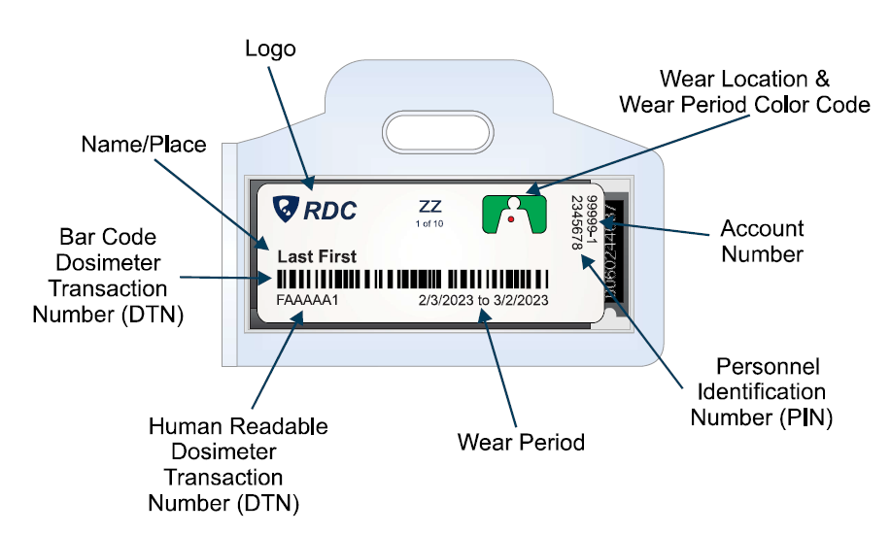
To view your radiation dose readings:
- Go to https://radetco.com/
- Click Dose Check on the top right corner
- In the Badge Number box enter the Human Readable Dosimeter Transaction Number
- In the Personal Identifier enter the Personal Identification Number
- Click Check

